M1 series mobility scooter delivers high-performance operation and easy disassembly for convenience on the go. It provides you extremely driving experience. Enjoy your perfect active lifestyle.

Functions:

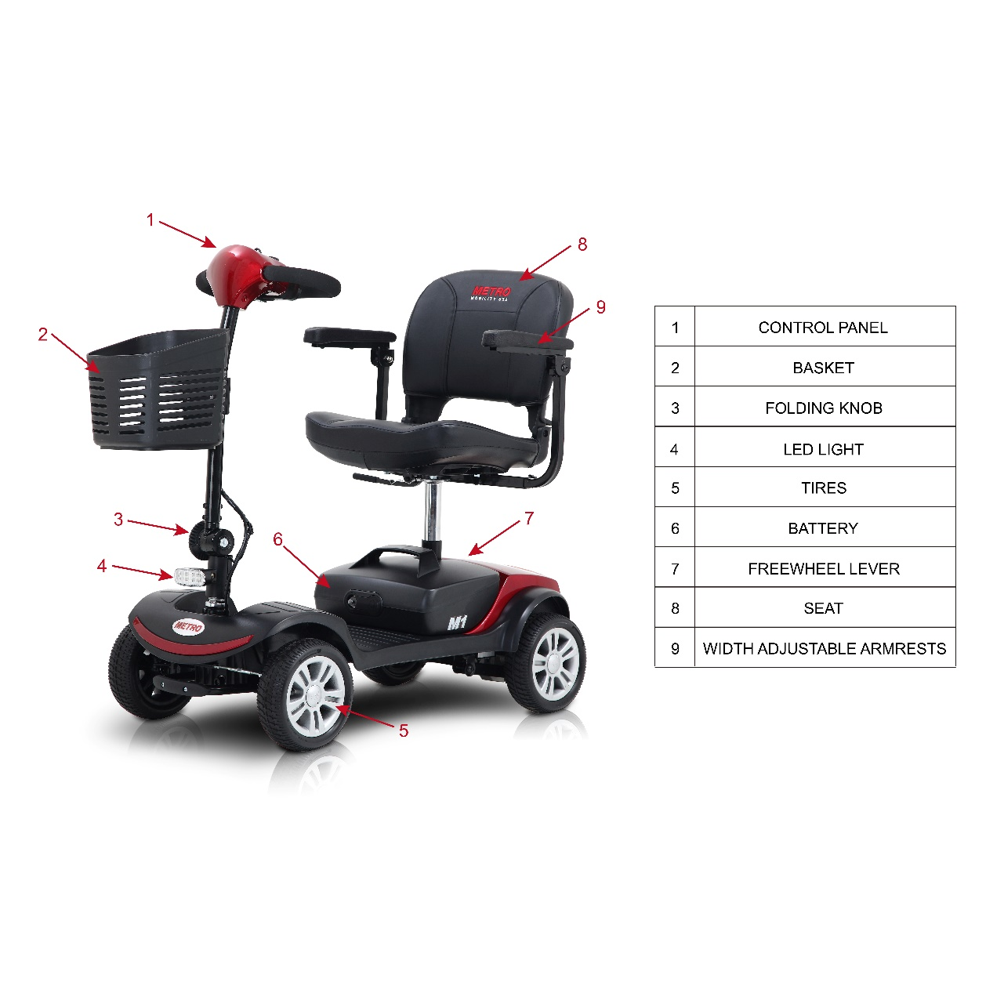
Features：特点
- High-performance operation and easy disassembly
- Sliding swivel seat with flip-up armrests
- Max forwarding speed: 4.97MPH
- Intelligent electromagnetic brake
5. Simple control panel can operate with fingertips or thumbs effortlessly。
6. Detachable basket
7. With anti-tip wheels
8. Weight capacity: 300lbs
9. Max driving gradient: 8°
10. Driving Range: 10 Miles
11. Rear suspension
12. Charging time: 6-8h
13. Red and Blue color options.
14. With front LED light and rear brake light

Details:
